Data Mining

Elbio Iseas

DBM/460

October 17, 2016

Daniel McDonald

**Introduction**

In the last phase of the dimensional model there was important entity missing that is here now, the time entity, which will use for data mining in an effort to discover the causes of slow performance of the legacy system with the analysis of the Time Entity using the its relevant data: year, quarter, month, day, and date and time. The data warehouse will allow users to run reports on existing information for visualization of sales customized by department, item, and date.

**Dimensional Model**

**LOGICAL DESIGN**

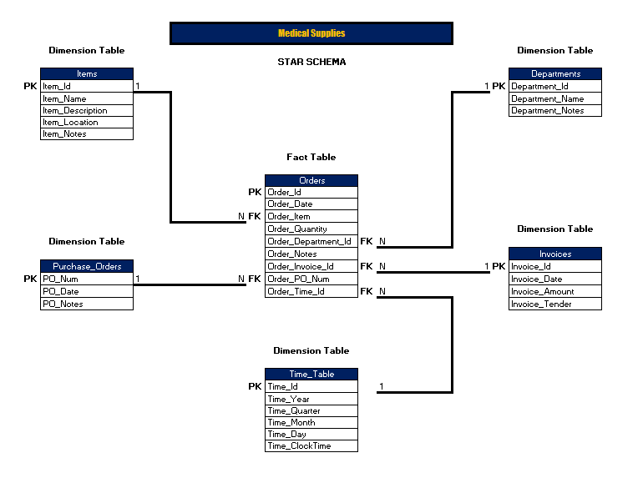

The use of the data warehouse will help management in the analysis of data coming from the operations as a tool to solve issues found in the processes of the old systems. Dashboards and report tools will be useful for monitoring transactions and results.

The data mining “a process does not have a beginning and an end: it is ongoing” (Ponniah, 2010), will help analyzing the data continuously entered in the data warehouse and returning information for the reports and other data mining. The purpose of data mining is to find “Meaningful Patterns and Rules” (Ponniah, 2010) in the big volume of company records (rows), saved in the data warehouse.

Data mining will improve Customer Relationship Management by studying customers’ purchases and their behavior regarding buying from the company, what, when, for how long, and allowing the chance to learn from their habits and act in consequence to get more revenues for the company.

Reports resulting from data mining include:

1. Several including Customers’ Information with their transactions and products (items),
2. Sales performed with charts by year, quarter, month, and day,
3. Sales by items with most sold by customer, and
4. Sales by items with least sold by customer.

**Conclusion**

The use of the data warehouse in combination with data mining and reports will give executives good tips to make right business decisions to stay competitive in market, and find solutions for existing system issues and prevent from future ones.

References

Ponniah, P (2010) Data Warehousing Fundamentals for IT Professionals, Second Edition. John Wiley & Sons, Inc.